Group: Gabreilla Cukier & Emilly Matias-Pereira
Professor Schwartz | CSC 650 | March 23, 2026
Project Description
This project aims to predict image memorability using the LaMem dataset. We focus on combining image features with emotion information to evaluate whether including emotions improves memorability predictions compared to using images alone.
Progress Update
Our material has been gathered by a dataset subset from LaMem. There is a total of 16815 that we have acquired via API requests. This subset was created by LaMem and appears on the “Explore” page of their website. The full dataset contains 60k images. We started an initial exploration of the dataset and performed pre-processing to facilitate the next steps of the project. For each image we generated:
- Dominant emotion (generated through the BLIP model): The LaMem dataset has information regarding the images' dominant emotion, but only for a small number of images (about 500 in our subset). The same emotion categories present in the original dataset were used for this preprocessing classification step. The images emotion categories are the following: amusement, excitement, awe, contentment, and sad.
- Brief caption consisting of the description of the ccontent of each of the images. This will not be used for the initial baseline model, but it could add value in future iterations. This was generated using the CLIP model.
- ViT embeddings of the images, generated in this step to accelerate training in the next step.
Below is an example of the original images we have gathered from LaMem along with their memorability score. The dominant emotion and captions were generated in the pre-processing step.
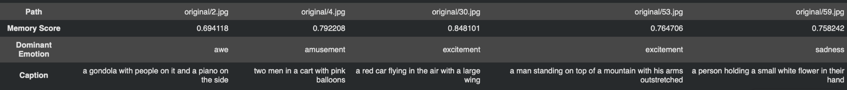

The process will consist of making an improved model with multiple inputs. We will include descriptions of the images, switch the generators imbeddings of the images ( change the ViT large, use possibly DINO), and finally create a feature engineering with the emotions. Overall, the final model is to compare the emotions in order to identify its impact.
Project Plan
Baseline Model
Our baseline model for the project consists of utilizing CLS token from the image’s ViT and one-hot encoding of the generated emotions, feeding them into a simple linear layer. The image below illustrates the proposed architecture.

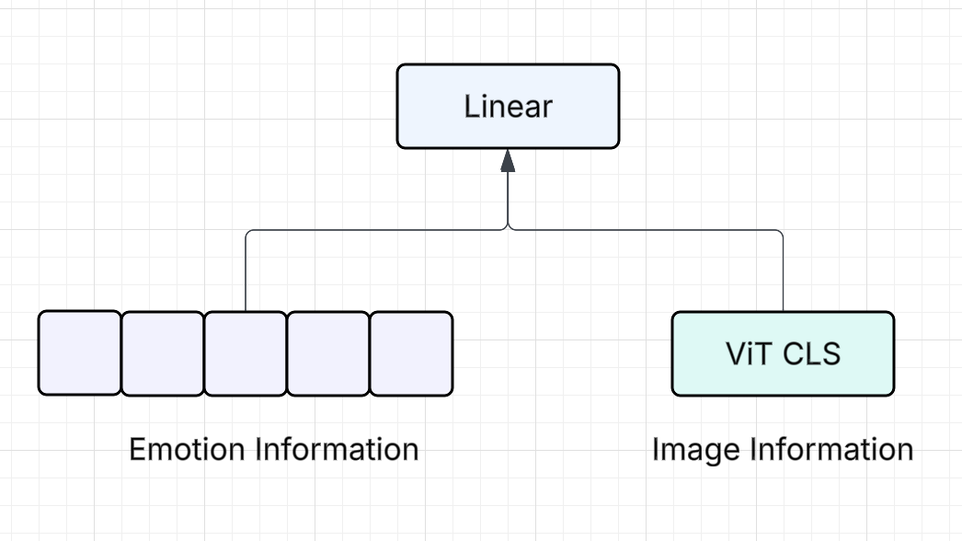

Possible Improvements
Potential improvements to the baseline, in order of priority, include:
- Instead of a simple linear layer, we could explore more complex architectures for the final prediction model.
- Include image descriptions in the input (as the ones generated from CLIP and possibly also more complex emotion descriptions)
- Switch the image embedding generator: for example, replacing the ViT-L/14 that we used with DINO embeddings.
- Feature engineering with the emotions: rather than simple one-hot encoding, we could test alternative formats. For instance, some studies use valence (how positive or negative an emotion is) and arousal (how intense or energetic the emotion is).
The final model will allow us to compare performance with and without emotion features to measure their actual impact on predictions.

Understanding and Predicting Image Memorability at a Large Scale. A. Khosla, A. S. Raju, A. Torralba and A. Oliva. International Conference on Computer Vision (ICCV), 2015. DOI 10.1109/ICCV.2015.275

